

Dr. Lisa, Ross inc.
2016-07-18
Dr. Ross
61046 Jennifer Stravenue, Greertown, ND 00965
Phone: 7736761645
Fax: 286172019

Re: Cheryl, Blevins
PHN: 2148154575
Birthdate: 02-Jun-1970
Address: 57770 Nathan Rue, Port Cherylborough, FM 06127
Patient number: 2407053461

To Whom It May Concern:

This is a medical letter to state the above patient is pregnant with expected delivery date of 21-Oct-2025. Hoping this information is satisfactory for your requirements.

Thank you.

Sincerely,
Dr. Lisa, Ross
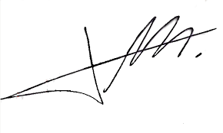
FRCS© NCMP
Clinical Assistant Professor, UBC
Department of Obstetrics and Gynecology SMH

